**NIAGARA FALLS HIGH SCHOOL**

**JUNIOR LAW ENFORCEMENT ACADEMY 2022-2023**



**“I hated every minute of training, but I said, don't quit. Suffer now and live the rest of your life as a champion."  
- Muhammad Ali**

JUNIOR LAW ENFORCEMENT ACADEMY OUTLINE

What is Law Enforcement?

A law enforcement officer is a government employee who is responsible for the prevention, investigation, apprehension, or detention of individuals suspected or convicted of offenses against the criminal laws, including an employee engaged in this activity who is transferred to a supervisory or administrative position; or serving as a probation or pretrial services officer.

For Purposes of This Course:

Law Enforcement shall include, all branches of the military (military police, security forces etc), all federal law enforcement agencies, state, county sheriff/police, city police, town police, probation, state corrections and county corrections officers

Objectives of This Course:

* To familiarize yourself with the physical training required to complete a law enforcement academy
* To physically prepare you for a law enforcement academy
* To encourage you to live and maintain a healthy lifestyle
* To maximize gains and minimize the risk for injury

What Do I Need for This Course?

We will be ordering uniforms (t-shirts/shorts) but for now…

* T-shirt
* Shorts
* Sneakers
* Notebook
* Pen/Pencil
* Heart

How Will I Be Graded?

* The best physical fitness test score at the end of the academy will receive an award
* You will be graded on a team effort

Curriculum

* NYS Cooper Standards Physical Fitness Test Once a Month
* Weight Training/Preparation
* Anaerobic/Aerobic Conditioning
* Law Enforcement Academy Familiarization
* How to Maintain Physical Fitness

**NYS Police Physical Fitness Standards**

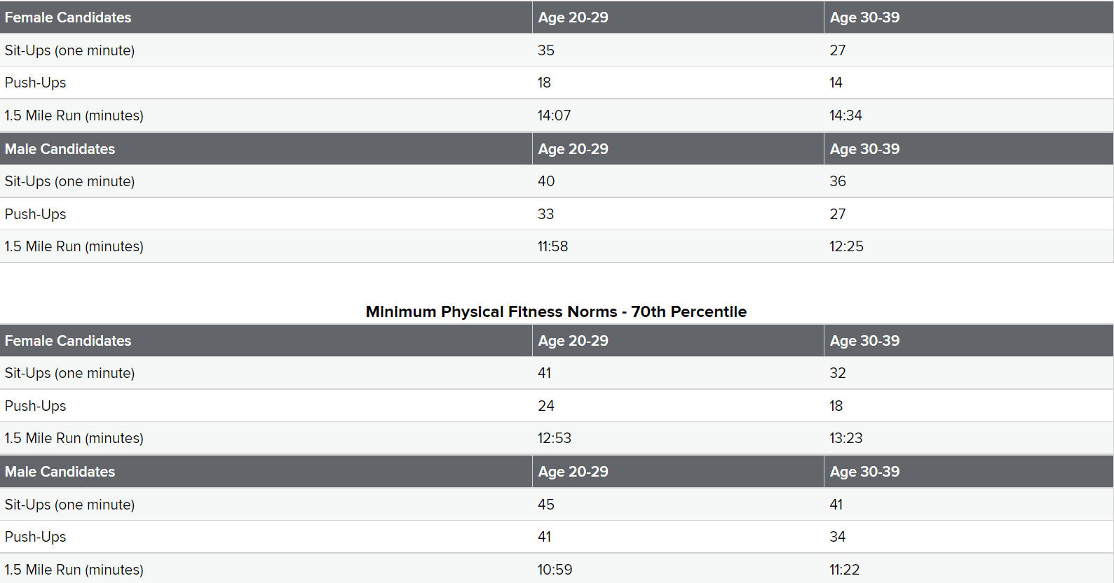

**Niagara County Law Enforcement Academy Physical Fitness Standards**

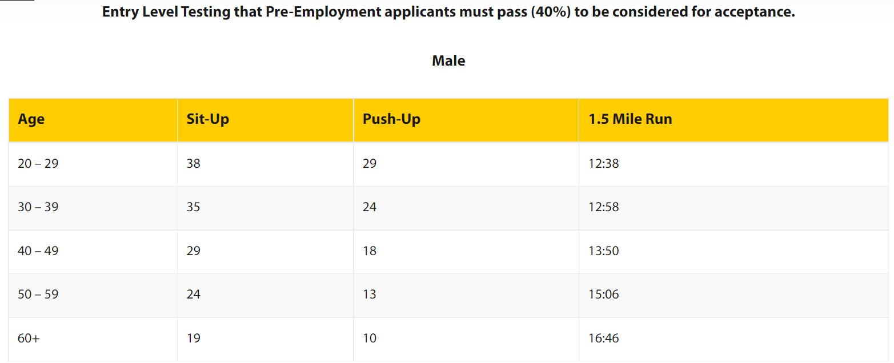

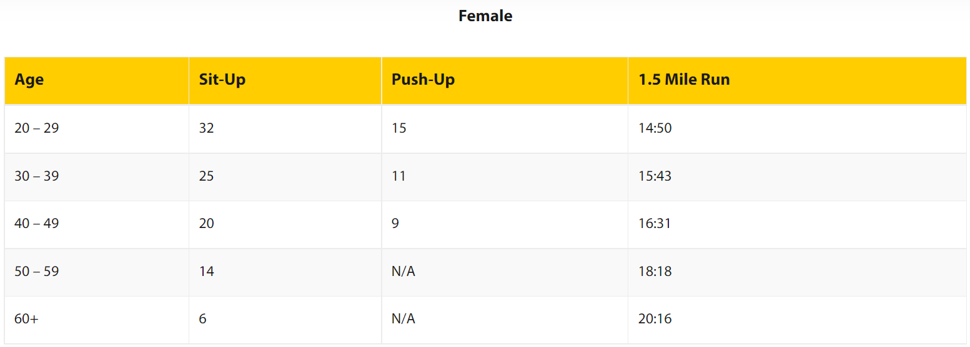

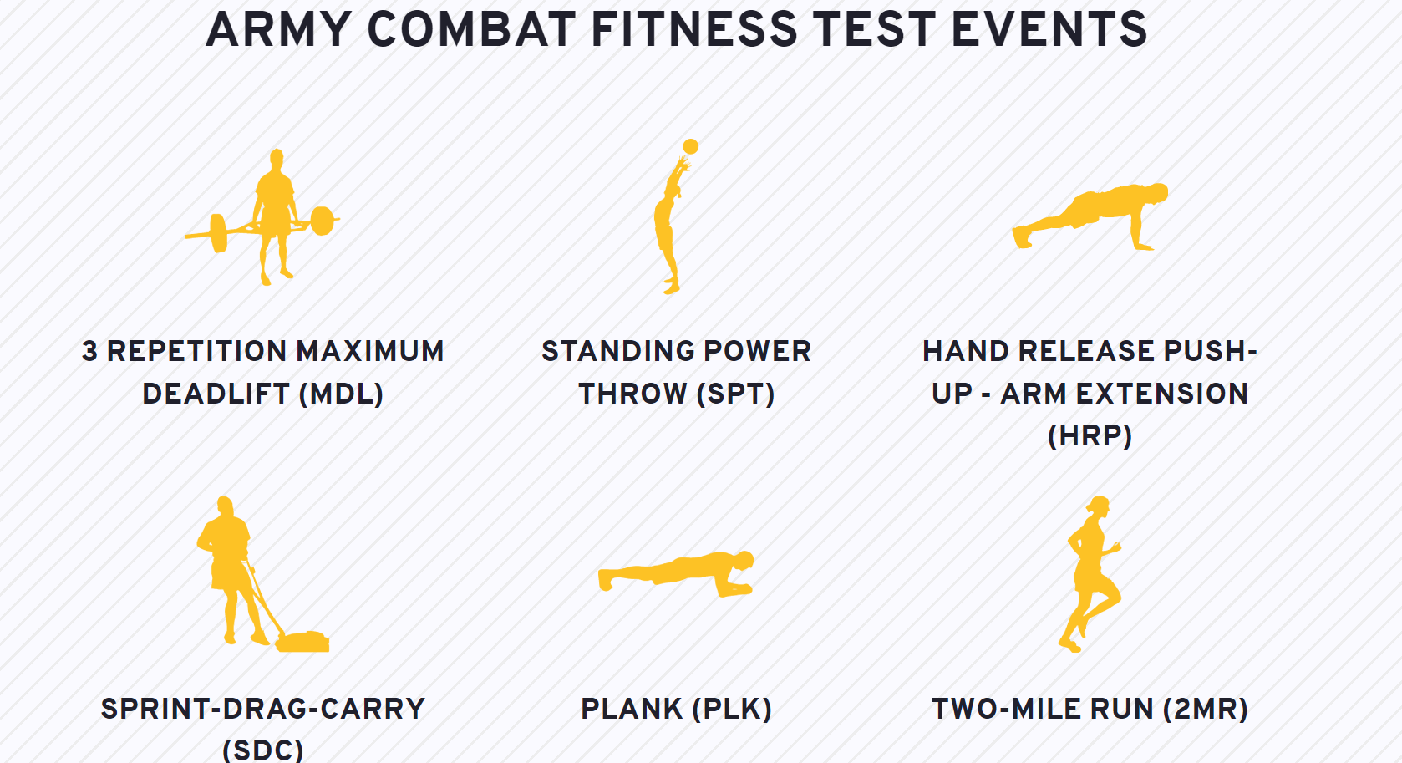**Army Combat Fitness Test**

**Army Combat Fitness Test Scoring Scale**

<https://www.army.mil/e2/downloads/rv7/acft/ACFT_scoring_scales_220323.pdf>

**Pre/Post Lifting General/Dynamic Warm Up and Static Cool Down**

**General Warm Up**

Purpose: To begin elevating the body’s temperature

*Choose an Option that Best Fits the Environment that you are Working With

Option 1: 15 Overhead Jumping Jacks, 15 Cross Overs, 15 Seal Jumping Jacks

Option 2: Jog on the treadmill for 5 minutes at a speed of 5-6.0

Option 3: Jog for 5 minutes in an open area

Option 4: Jog in place for 2-3 minutes

**Lower Body Dynamic Warm Up**

General Warm Up

Body Weight Squats – 1 x 12 reps

Back Bridge – 1 set x 12 reps

Supine Straight Leg Raise – 2 sets x 10 each leg

Bent Knee Iron Cross – 1 set x 10 each side

Roll Over into V-Sits – 1 set x 10

Bird Dogs 1 set x 10 each leg

Hip Circles In – 1 set x 10 reps each leg

Hip Circles Out – 1 set x 10 reps each leg

Scorpions – 1 set x 8 reps each leg

Alternate Groiners 1 set x 10 reps each leg

Static Hip Flexor Stretch – 1 set x 15-30 seconds each leg

Static Calf Stretch – 1 set x 15-30 seconds each leg

Static Pec Stretch – 1 set x 15-30 seconds each arm

**Upper Body Dynamic Warm Up**

Basic Overhead Jumping Jacks – 1 set x 15 reps

Seal Jumping Jacks – 1 set x 15 reps

Cross Over Jumping Jacks – 1 set x 15 reps

Body Weight Squats – 1 set x 10 reps

Pushups – 1 set x 15 reps

Ground Touches (Lats) – 1 set x 10 touches with each arm

Bent Knee Iron Cross – 1 set x 10 each side

Band Pull Aparts – 1 x 6 reps

Diagonal Band Pull Aparts – 1 x 12 reps (6 each way)

Band Shoulder Dislocations – 1 set x 10 each way

W’s w/Band – 1 set x 12

Band Pulls – 1 set x 10

Static Lat Stretch – 1 set x 15 sec each arm (only when starting with chest exercise)

Static Pec Stretch – 1 set x 15 sec each arm (only when starting with a lat exercise)

Internal Rotation – 1 set x 6 reps each arm

**Full Body Dynamic Warm Up (For a Upper/Lower Body Lifting Day)**

Basic Overhead Jumping Jacks – 1 set x 15 reps

Cross Over Jumping Jacks – 1 set x 15 reps

Body Weight Squats – 1 set x 10 reps

Pushups – 1 set x 15 reps

Ground Touches (Lats) – 1 set x 10 reps each side

Bent Knee Iron Cross – 1 set x 10 each side

Supine Straight Leg Raise – 1 set x 15 each side

Groiners – 1 set x 8 each leg

Roll Over into V-Sits – 1 set x 8

Band Dislocations – 1 set x 10 each way

**Full Body Dynamic Warm Up (For Conditioning)**

*Each stretch you should do for about 15 yards*

2 Laps around the Field (Only to the 50 Yard Line)

15 Regular Jumping Jacks

15 Crossing Overs

15 Pushups (Palms)

Neck Rolls x 10 each way

Quick Skips Forwards

Quick Backwards

Power Skips Forwards

Power Skips Backwards

Buttkickers

Backpedals

Lateral Leap Frog x 2

Lateral Toe Touches

Knee Tucks

Bent Over Quad Pulls

Over The Fence, Under the Fence x 2

Front Lunge with a Twist

Front Lunge with a Reach Toward Lead Leg

Inch Worms

Build Ups

50% (Backpedal for 10 Yards then Sprint to About the 30-40 Yard Line)

75% (Starting in your Offensive Stance)

100% (Starting in your Offensive Stance)

**Full Body Static Stretch**

*Use Only When Body Temperature is Highly Elevated (Post-Workout)

*Hold Everything for at Least 10-15 Seconds

*More Than One Set can be Performed if Desired

Do While Standing

Neck Straight Back

Neck Forward

Neck to Right/Left Side

Right/Left Arm Across

Right/Left Arm Over Top

Pull Finger Back on Right/Left Arm (Forearms)

Hands on Hips Lean Back (Abs)

Hands Over Head Lean to the Right/Left (Obliques)

Bend Over, Touch Toes with Feet Together

Feet Spread, Lean to Right/Left/Middle

Left/Right Leg Forward, Calf Stretch

Right/Left Leg Forward, Lean to Lead Leg Side (Hip Flexor)

Do While Sitting

Left Leg out, Right Leg in, Touch Toes with Right Hand then Both Hands

Right Leg out, Left Leg in, Touch Toes with Left Hand then Both Hands

Left Leg out, Right Leg Over, Twist Towards Right Side

Right Leg out, Left Leg Over, Twist Towards Left Side

Do While on Back

Pull Right/Left Knee to Chest

Right Knee to Left, Twist to Right

Left Knee to Right, Twist to Left

Roll Back, Try to Get the Knees to Ground

**Example of Pre-Bench, Squat or Deadlift Warm Up**

Example of a warm up for a working set of 135 for 10 Reps

45 X 10  
75X 5  
95 X 3  
115 X 3  
135 X 10

* The reason behind this style of warm up is to get multiple warm up sets in but keeping the reps low so that you don’t waste energy for your working sets.

**\*Notes\***

* Workouts should be treated just like a sports practice or game. They require just as much of a warm up.
* Make sure to be very easy at the start of the warm up. Each body part of each repetition should be stretched slightly farther than the previous repetition.
* A static stretch can also be thrown into the mix. It can be performed during any down time that you have during your workout to help increase flexibility and range of motion. It also might help with muscle recovery in between workouts (perform post workout or before you go to sleep).

**NFHS Jr. Law Enforcement Academy**

**Workout Program 09/12/22 – 10/30/22**

|  |  |  |  |
| --- | --- | --- | --- |
| **Day 1** | **Week 1**  **09/12** | **Week 2**  **09/19** | **Week 3**  **09/26** |
| Bodyweight | lbs | lbs | lbs |
| Lower Body Dynamic Warm Up |  |  |  |
| Box Squat **(3x10)** |  |  |  |
| Bulgarian Split Squats **(3x10)** |  |  |  |
| Supine 1-Leg Hip Thrusts **(3x10 each leg)** |  |  |  |
| Dumbbell Sprinter Lunges **(3x10 steps each leg)** |  |  |  |
| Calf Raises **(3x6 each side of foot)** |  |  |  |
| Superset  Internal Rotation **(2x10 each arm)**  External Rotation **(2x10 each arm)**  Diagonal Flexion **(2x10 each arm)**  Diagonal Extension **(2x10 each arm)** |  |  |  |
| SUPERSET  Prone Planks – **(3x30 Seconds)**  Sprinter Sit-ups – **(3x10 on Each Leg)**  Toe Touches – **(3x10)** |  |  |  |

|  |  |
| --- | --- |
| **Full Body Workout** | **09/19** |
| Full Body Dynamic Warm Up |  |
| Flat Dumbbell Presses **(3x12)** |  |
| Single Arm Rows **(3x12)** |  |
| Frontal + Lateral Raises **(3x10 each way)** |  |
| Reverse Flys **(3x12)** |  |
| Bulgarian Split Squats **(3x10 each leg)** |  |
| Step-Ups **(3x10 each leg)** |  |
| Supine 1-Leg Hip Thrusts **(3x10 each leg)** |  |
| Single Leg Deadlifts **(3x10 each leg)** |  |
| Calf Raises **(3x15 or until failure)** |  |
| Superset  Internal Rotation **(2x10 each arm)**  External Rotation **(2x10 each arm)**  Diagonal Flexion **(2x10 each arm)**  Diagonal Extension **(2x10 each arm)** |  |
| **Conditioning/Abs**  Sprinter Lunges – **(walk to door and back)**  Push-Ups – **(TBD)**  Planks – **(3x30 sec)**  Side Planks **(3x15 sec)**  Leg Lifts **(3x10)**  Toe Touches **(until I say stop)** |  |

**Full Body Dynamic Warm Up (For a Upper/Lower Body Lifting Day)**

Basic Overhead Jumping Jacks – 1 set x 15 reps

Cross Over Jumping Jacks – 1 set x 15 reps

Body Weight Squats – 1 set x 10 reps

Pushups – 1 set x 15 reps

Ground Touches (Lats) – 1 set x 10 reps each side

Bent Knee Iron Cross – 1 set x 10 each side

Supine Straight Leg Raise – 1 set x 15 each side

Groiners – 1 set x 8 each leg

Roll Over into V-Sits – 1 set x 8

Band Dislocations – 1 set x 10 each way

|  |  |  |  |
| --- | --- | --- | --- |
| **Full Upper Body Workout** | **Week 1**  **09/19** | **Week 2**  **09/27** | **Week 3**  **10/03** |
| Bodyweight | lbs | lbs | lbs |
| Upper Body Dynamic Warm Up |  |  |  |
| Flat Dumbbell Presses **(3x12)** |  |  |  |
| Single Arm Rows **(3x12)** |  |  |  |
| Frontal + Lateral Raises **(3x10 each way)** |  |  |  |
| Reverse Flys **(3x12)** |  |  |  |
| Dumbbell Skull Crushers **(3x12)** |  |  |  |
| Hammer Curls **(3x12)** |  |  |  |
| Prone Planks **(3x30 sec)**  Side Planks **(3x20 sec each side)**  Leg Lifts **(3x10)**  Toe Touches **(until I say stop)** |  |  |  |
| Conditioning TBD |  |  |  |

**Upper Body Dynamic Warm Up**

Basic Overhead Jumping Jacks – 1 set x 15 reps

Seal Jumping Jacks – 1 set x 15 reps

Cross Over Jumping Jacks – 1 set x 15 reps

Body Weight Squats – 1 set x 10 reps

Pushups – 1 set reps

Ground Touches (Lats) – 1 set x 10 touches with each arm

Bent Knee Iron Cross – 1 set x 10 each side

Band Shoulder Dislocations – 1 set x 10 each way

Band Pull Aparts – 1 x 10 reps

Diagonal Band Pull Aparts – 1 x 10 reps (10 each way)

Band Pulls – 1 set x 10

W’s w/Band – 1 set x 10

Static Lat Stretch – 1 set x 15 sec each arm (only when starting with chest exercise)

Static Pec Stretch – 1 set x 15 sec each arm (only when starting with a lat exercise)

|  |  |  |  |
| --- | --- | --- | --- |
| **Full Lower Body Workout** | **Week 1**  **09/21** | **Week 2**  **09/29** | **Week 3**  **10/05** |
| Bodyweight | lbs | lbs | lbs |
| Lower Body Dynamic Warm Up |  |  |  |
| **(3x10)** |  |  |  |
| Bulgarian Split Squats **(3x10)** |  |  |  |
| Eccentric Hamstring Curls w/partner **(3x10)** |  |  |  |
| Supine 1-Leg Hip Thrusts **(3x10 each leg)** |  |  |  |
| Single Leg Deadlifts **(3x10 each leg)** |  |  |  |
| Calf Raises **(3x until failure)** |  |  |  |
| Barbell Hurdles **(3x10 front, reverse, side)** |  |  |  |
| **As a Group** |  |  |  |
| Sprinter Lunges **(3x10 steps each leg)** |  |  |  |
| Prone Planks **(3x30 Seconds)** |  |  |  |
| Sprinter Sit-ups **(3x10 on Each Leg)** |  |  |  |
| Leg Lifts **(3x10)** |  |  |  |
| Toe Touches **(3x until failure)** |  |  |  |

**Lower Body Dynamic Warm Up**

General Warm Up

Jumping Jacks – 1 x 20 reps

Body Weight Squats – 1 x 12 reps

Back Bridge – 1 set x 12 reps

Supine Straight Leg Raise – 2 sets x 10 each leg

Bent Knee Iron Cross – 1 set x 10 each side

Roll Over into V-Sits – 1 set x 10

Bird Dogs 1 set x 10 each leg

Hip Circles In – 1 set x 10 reps each leg

Hip Circles Out – 1 set x 10 reps each leg

~~Scorpions – 1 set x 8 reps each leg~~

Alternate Groiners 1 set x 10 reps each leg

Static Hip Flexor Stretch – 1 set x 15-30 seconds each leg

Static Calf Stretch – 1 set x 15-30 seconds each leg

~~Static Pec Stretch – 1 set x 15-30 seconds each arm~~

|  |  |  |
| --- | --- | --- |
| **Full Upper Body Workout** | **Week 1**  **09/23** | **Week 3**  **10/07** |
| Bodyweight | lbs | lbs |
| Upper Body Dynamic Warm Up |  |  |
| Incline Dumbbell Presses **(3x12)** |  |  |
| Assisted Pull-Ups **(3x10)** |  |  |
| Frontal **(3x10)** |  |  |
| Lateral Raises **(3x10)** |  |  |
| Band Pull-Aparts **(3x until failure)** |  |  |
| Dumbbell Rolling Extensions **(3x12)** |  |  |
| Incline Curls **(3x12)** |  |  |
| Plate Holds **(3x30 sec)** |  |  |
| Dumbbell Gauntlet **(2 sets 20, 20, 15, 15, 10 reps)** |  |  |
| Prone Planks Pushup Position **(3x30 seconds)** |  |  |
| Oblique Twist w/plate **(3x10 each side)** |  |  |
| Sprinter Sit-ups **(3x10 on each leg)** |  |  |
| Toe Touches **(until I say stop)** |  |  |
| Conditioning TBD |  |  |

**Upper Body Dynamic Warm Up**

Basic Overhead Jumping Jacks – 1 set x 15 reps

Seal Jumping Jacks – 1 set x 15 reps

Cross Over Jumping Jacks – 1 set x 15 reps

Body Weight Squats – 1 set x 10 reps

Pushups – 1 set reps

Ground Touches (Lats) – 1 set x 10 touches with each arm

Bent Knee Iron Cross – 1 set x 10 each side

Band Shoulder Dislocations – 1 set x 10 each way

Band Pull Aparts – 1 x 10 reps

Diagonal Band Pull Aparts – 1 x 10 reps (10 each way)

Band Pulls – 1 set x 10

W’s w/Band – 1 set x 10

Static Lat Stretch – 1 set x 15 sec each arm (only when starting with chest exercise)

Static Pec Stretch – 1 set x 15 sec each arm (only when starting with a lat exercise)

|  |  |  |  |
| --- | --- | --- | --- |
| **Full Upper Body Workout** | **Week 4**  **10/12** | **Week 5**  **10/19** | **Week 6**  **10/25** |
| Upper Body Dynamic Warm Up |  |  |  |
| Optional Bench Press **(3x10)** | x10 x10 x10 | x10 x10 x10 | x10 x10 x10 |
| 1-Arm Dumbbell Presses **(3x10)** | x10 x10 x10 | x10 x10 x10 | x10 x10 x10 |
| Bent-Over Rows or Reverse Rows **(3x10)** | x10 x10 x10 | x10 x10 x10 | x10 x10 x10 |
| Dumbbell Military Press **(3x10)** | x10 x10 x10 | x10 x10 x10 | x10 x10 x10 |
| Seated Lateral Raises **(3x10)** | x10 x10 x10 | x10 x10 x10 | x10 x10 x10 |
| Reverse Flys w/Bands **(3x12)** | x12 x12 x12 | x12 x12 x12 | x12 x12 x12 |
| Incline Dumbbell Skull Crushers **(3x12)** | x12 x12 x12 | x12 x12 x12 | x12 x12 x12 |
| Curls – Your Choice **(3x12)** | x12 x12 x12 | x12 x12 x12 | x12 x12 x12 |
| Dumbbell Gauntlet **(2 sets 20, 20, 15, 15, 10 reps)** |  |  |  |
| Superset  Weighted Sit-ups w/Plate **(3x30 sec)**  Weighted Oblique Side Bends **(3x10 each)** |  |  |  |
| Flutter Kicks **(3x30 sec)** |  |  |  |

**Upper Body Dynamic Warm Up**

Basic Overhead Jumping Jacks – 1 set x 15 reps

Seal Jumping Jacks – 1 set x 15 reps

Cross Over Jumping Jacks – 1 set x 15 reps

Body Weight Squats – 1 set x 10 reps

Pushups – 1 set 10 reps

Ground Touches (Lats) – 1 set x 10 touches with each arm

Bent Knee Iron Cross – 1 set x 10 each side

Band Shoulder Dislocations – 1 set x 10 each way

Band Pull Aparts – 1 x 10 reps

Diagonal Band Pull Aparts – 1 x 10 reps (10 each way)

Band Pulls – 1 set x 10

W’s w/Band – 1 set x 10

|  |  |  |  |
| --- | --- | --- | --- |
| **Full Lower Body Workout** | **Week 4**  **10/14** | **Week 5**  **10/21** | **Week 6**  **10/27** |
| Lower Body Dynamic Warm Up |  |  |  |
| Back Squats **(3x10)** | x10 x10 x10 | x10 x10 x10 | x10 x10 x10 |
| Bulgarian Split Squats **(3x10)** | x10 x10 x10 | x10 x10 x10 | x10 x10 x10 |
| Barbell Stiff Leg Deadlifts **(3x10)** | x10 x10 x10 | x10 x10 x10 | x10 x10 x10 |
| Eccentric Hamstring Curls w/partner **(3x10)** | x10 x10 x10 | x10 x10 x10 | x10 x10 x10 |
| Dumbbell Step-Ups **(3x10 each leg)** | x10 x10 x10 | x10 x10 x10 | x10 x10 x10 |
| Single Leg Deadlifts **(3x10 each leg)** | x10 x10 x10 | x10 x10 x10 | x10 x10 x10 |
| Single Leg Calf Raises **(3x until failure)** |  |  |  |
| Barbell Hurdles **(3x10 front, reverse, side)** |  |  |  |
| **As a Group** |  |  |  |
| Sprinter Lunges **(3x10 steps each leg)** |  |  |  |
| Superset  Prone Planks **(3x30 secs)**  Sprinter Sit-ups **(3x10 on each leg)** |  |  |  |
| Superset  Bicycle Crunches **(3x30 sec)**  Heal Taps **(3x10 on each leg)** |  |  |  |

**Lower Body Dynamic Warm Up**

General Warm Up

Jumping Jacks – 1 x 20 reps

Body Weight Squats – 1 x 12 reps

Back Bridge – 1 set x 12 reps

Supine Straight Leg Raise – 2 sets x 10 each leg

Bent Knee Iron Cross – 1 set x 10 each side

Roll Over into V-Sits – 1 set x 10

Bird Dogs 1 set x 10 each leg

Hip Circles In – 1 set x 10 reps each leg

Hip Circles Out – 1 set x 10 reps each leg

Alternate Groiners 1 set x 10 reps each leg

Static Hip Flexor Stretch – 1 set x 15-30 seconds each leg

Static Calf Stretch – 1 set x 15-30 seconds each leg

|  |  |  |  |
| --- | --- | --- | --- |
| **Full Upper Body Workout** | **Week 7**  **10/31** | **Week 8**  **11/09** | **Week 9**  **11/14** |
| Upper Body Dynamic Warm Up |  |  |  |
| Bench Press **(3x8)** | x8 x8 x8 | x8 x8 x8 | x6 x6 x6 |
| Dumbbell Presses **(3x8)** | x8 x8 x8 | x8 x8 x8 | x6 x6 x6 |
| Rows w/Bands **(3x10)** | x10 x10 x10 | x10 x10 x10 | x10 x10 x10 |
| Barbell Shrugs **(3x10)** | x10 x10 x10 | x10 x10 x10 | x10 x10 x10 |
| Superset  Frontal Raises w/Plate **(3x10)**  Band Pull Aparts Until Failure | x10 x10 x10 | x10 x10 x10 | x10 x10 x10 |
| Incline Reverse Flys **(3x12)** | x12 x12 x12 | x12 x12 x12 | x12 x12 x12 |
| Dumbbell Overhead Extensions **(3x12)** | x12 x12 x12 | x12 x12 x12 | x12 x12 x12 |
| Incline Dumbbell Curls – **(3x12)** | x12 x12 x12 | x12 x12 x12 | x12 x12 x12 |
| Situps **(3x until failure)** |  |  |  |
| Side Planks **(3x35 sec on each side)** |  |  |  |

**Upper Body Dynamic Warm Up**

Basic Overhead Jumping Jacks – 1 set x 15 reps

Seal Jumping Jacks – 1 set x 15 reps

Cross Over Jumping Jacks – 1 set x 15 reps

Body Weight Squats – 1 set x 10 reps

Pushups – 1 set 10 reps

Ground Touches (Lats) – 1 set x 10 touches with each arm

Bent Knee Iron Cross – 1 set x 10 each side

Band Shoulder Dislocations – 1 set x 10 each way

Band Pull Aparts – 1 x 10 reps

Diagonal Band Pull Aparts – 1 x 10 reps (10 each way)

Band Pulls – 1 set x 10

W’s w/Band – 1 set x 10

|  |  |  |
| --- | --- | --- |
| **Full Lower Body Workout** | **Week 7**  **11/02** | **Week 9**  **11/16** |
| Lower Body Dynamic Warm Up |  |  |
| Back Squats **(3x8)** | x8 x8 x8 | x6 x6 x6 |
| Elevated Split Squats **(3x8)** | x8 x8 x8 | x6 x6 x6 |
| Dumbbell Romanian Deadlifts **(3x10)** | x10 x10 x10 | x10 x10 x10 |
| Eccentric Hamstring Curls w/partner **(3x10)** | x10 x10 x10 | x10 x10 x10 |
| Single Leg Deadlifts **(3x10 each leg)** | x10 x10 x10 | x10 x10 x10 |
| Calf Raises – Your Choice **(3x until failure)** |  |  |
| Barbell Hurdles **(3x10 front, reverse, side)** |  |  |
| **As a Group** |  |  |
| Sprinter Lunges **(3x10 steps each leg)** |  |  |
| Superset  Prone Planks **(3x30 secs)**  Sprinter Sit-ups **(3x10 on each leg)** |  |  |
| Superset  Bicycle Crunches **(3x30 sec)**  Heal Taps **(3x10 on each leg)** |  |  |

**Lower Body Dynamic Warm Up**

General Warm Up

Jumping Jacks – 1 x 20 reps

Body Weight Squats – 1 x 12 reps

Back Bridge – 1 set x 12 reps

Supine Straight Leg Raise – 2 sets x 10 each leg

Bent Knee Iron Cross – 1 set x 10 each side

Roll Over into V-Sits – 1 set x 10

Bird Dogs 1 set x 10 each leg

Hip Circles In – 1 set x 10 reps each leg

Hip Circles Out – 1 set x 10 reps each leg

Alternate Groiners 1 set x 10 reps each leg

Static Hip Flexor Stretch – 1 set x 15-30 seconds each leg

Static Calf Stretch – 1 set x 15-30 seconds each leg

|  |  |
| --- | --- |
| **Full Upper Body Workout** | **Week 7**  **11/04** |
| Upper Body Dynamic Warm Up |  |
| Barbell Incline Press **(3x8)** |  |
| Incline Dumbbell Presses **(3x8)** |  |
| Laying/Supported Row **(3x10)** |  |
| Renegade Dumbbell Row **(3x10 each arm)** |  |
| Upright Barbell Rows **(3x10)** |  |
| Superset  Pulldowns w/Bands **(3x until failure)**  Hammer Curls **(3x until failure)** |  |
| Dumbbell Gauntlet **(2 sets 20, 20, 15, 15, 10 reps)** |  |
| Plate Holds **(3x30 sec)** |  |
| Abs TBD |  |

**Upper Body Dynamic Warm Up**

Basic Overhead Jumping Jacks – 1 set x 15 reps

Seal Jumping Jacks – 1 set x 15 reps

Cross Over Jumping Jacks – 1 set x 15 reps

Body Weight Squats – 1 set x 10 reps

Pushups – 1 set reps

Ground Touches (Lats) – 1 set x 10 touches with each arm

Bent Knee Iron Cross – 1 set x 10 each side

Band Shoulder Dislocations – 1 set x 10 each way

Band Pull Aparts – 1 x 10 reps

Diagonal Band Pull Aparts – 1 x 10 reps (10 each way)

|  |  |  |  |
| --- | --- | --- | --- |
| **Full Upper Body Workout** | **Week 10**  **11/28** | **Week 11**  **12/06** | **Week 12**  **12/12** |
| Upper Body Dynamic Warm Up |  |  |  |
| Bench Press | x8 x8 x8 | x8 x8 x8 | x6 x6 x6 |
| Hammer Strength Pulldowns | x8 x8 x8 | x8 x8 x8 | x6 x6 x6 |
| Dumbbell Presses w/bands | x8 x8 x8 | x8 x8 x8 | x6 x6 x6 |
| Hammer Strength Rows | x8 x8 x8 | x8 x8 x8 | x8 x8 x8 |
| Superset  Barbell Shrugs  Dumbbell or Plate Lateral Raises | x10 x10 x10    x10 x10 x10 | x10 x10 x10  x10 x10 x10 | x10 x10 x10  x10 x10 x10 |
| Standing or Laying Reverse Flys | x12 x12 x12 | x12 x12 x12 | x12 x12 x12 |
| Plate Holds | 3 Sets of 30 Seconds | 3 Sets of 35 Seconds | 3 Sets of 35 Seconds |
| Curls of Your Choice | x12 x12 x12 | x12 x12 x12 | x12 x12 x12 |
| Conditioning/Abs TBD |  |  |  |

**Upper Body Dynamic Warm Up**

Basic Overhead Jumping Jacks – 1 set x 15 reps

Seal Jumping Jacks – 1 set x 15 reps

Cross Over Jumping Jacks – 1 set x 15 reps

Body Weight Squats – 1 set x 10 reps

Pushups – 1 set 10 reps

Ground Touches (Lats) – 1 set x 10 touches with each arm

Bent Knee Iron Cross – 1 set x 10 each side

Band Shoulder Dislocations – 1 set x 10 each way

Band Pull Aparts – 1 x 10 reps

Diagonal Band Pull Aparts – 1 x 10 reps (10 each way)

Band Pulls – 1 set x 10

W’s w/Band – 1 set x 10

|  |  |  |  |
| --- | --- | --- | --- |
| **Full Lower Body Workout** | **Week 10**  **11/30** | **Week 11**  **12/06** | **Week 12**  **12/12** |
| Lower Body Dynamic Warm Up |  |  |  |
| Back Squats | x8 x8 x8 | x6 x6 x6 | x6 x6 x6 |
| Rack Pulls | x8 x8 x8 | x6 x6 x6 | x6 x6 x6 |
| Barbell Romanian Deadlifts | x10 x10 x10 | x10 x10 x10 | x10 x10 x10 |
| Eccentric Hamstring Curls w/partner | x10 x10 x10 | x10 x10 x10 | x10 x10 x10 |
| Calf Raises – Your Choice **(3x until failure)** |  |  |  |
| Barbell Hurdles **(3x10 front, reverse, side)** |  |  |  |
| **As a Group** |  |  |  |
| Sprinter Lunges **(3x10 steps each leg)** |  |  |  |
| Superset  Prone Planks **(3x30 secs)**  Knee Tucks **(3x10 on each leg)** |  |  |  |
| Superset  Bicycle Crunches **(3x30 sec)**  Heal Taps **(3x10 on each leg)** |  |  |  |

**Lower Body Dynamic Warm Up**

General Warm Up

Jumping Jacks – 1 x 20 reps

Body Weight Squats – 1 x 12 reps

Back Bridge – 1 set x 12 reps

Supine Straight Leg Raise – 2 sets x 10 each leg

Bent Knee Iron Cross – 1 set x 10 each side

Roll Over into V-Sits – 1 set x 10

Bird Dogs 1 set x 10 each leg

Hip Circles In – 1 set x 10 reps each leg

Hip Circles Out – 1 set x 10 reps each leg

Alternate Groiners 1 set x 10 reps each leg

Static Hip Flexor Stretch – 1 set x 15-30 seconds each leg

Static Calf Stretch – 1 set x 15-30 seconds each leg

|  |  |  |
| --- | --- | --- |
| **Full Upper Body Workout** | **Week 10**  **12/02** | **Week 12**  **12/16** |
| Upper Body Dynamic Warm Up |  |  |
| Barbell Incline Press **(3x8)** |  |  |
| Incline Dumbbell Presses **(3x8)** |  |  |
| Laying/Supported DB Rows **(3x10)** |  |  |
| Renegade Dumbbell Row **(3x10 each arm)** |  |  |
| Face pulls w/bands **(3x10)** |  |  |
| Superset  Pulldowns w/Bands **(3x until failure)**  Hammer Curls **(3x until failure)** |  |  |
| Dumbbell Gauntlet **(2 sets 20, 20, 15, 15, 10 reps)** |  |  |
| Plate Holds **(3x30 sec)** |  |  |
| Abs TBD |  |  |

**Upper Body Dynamic Warm Up**

Basic Overhead Jumping Jacks – 1 set x 15 reps

Seal Jumping Jacks – 1 set x 15 reps

Cross Over Jumping Jacks – 1 set x 15 reps

Body Weight Squats – 1 set x 10 reps

Pushups – 1 set reps

Ground Touches (Lats) – 1 set x 10 touches with each arm

Bent Knee Iron Cross – 1 set x 10 each side

Band Shoulder Dislocations – 1 set x 10 each way

Band Pull Aparts – 1 x 10 reps

Diagonal Band Pull Aparts – 1 x 10 reps (10 each way)